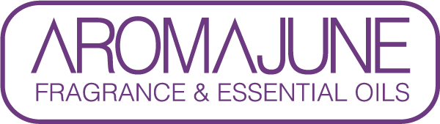

DATE : {{DATE}}
TO : {{CUSTOMER}}
SUBJCET : Methyl-N-Methylanthranilate CERTIFICATE
PRODUCT NAME : {{PRODUCT}}

AROMAJUNE hereby confirms that, to the best of our knowledge, the above-mentioned product contains:
- Methyl-N-methylanthranilate (MNMA, CAS No. 85-91-6) 00.00%

